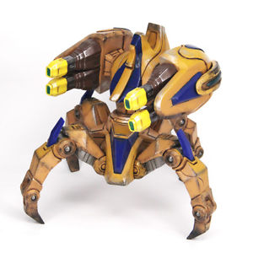Final project proposal

Mechatronics

Anqi Li 2019-spring

Battle Robot

* Introduction

Battle Robot is a project of battle game with Arduino robot. In this game, each player will control one battle robot in the battle ground to fight with other players. Each robot has three health points, and every robot has a weakness point at the back of it. Once one robot gets heated on the weakness point it will lose one HP, and the robot will die after three attacks on the weakness point. There will be no less than two and no more than five robots per game, and each game will last for five minutes.

Players will use smartphones to control robots to move and rotate. In addition, each robot has three modes to transform: the first is the basic mode, which allows robots to walk in all directions and do the in-place rotation; the second mode allows robots to move faster but slowly rotate; and the third mode helps robots to hide the weakness point but limits them to only rotate in-place.

* The flow diagrams

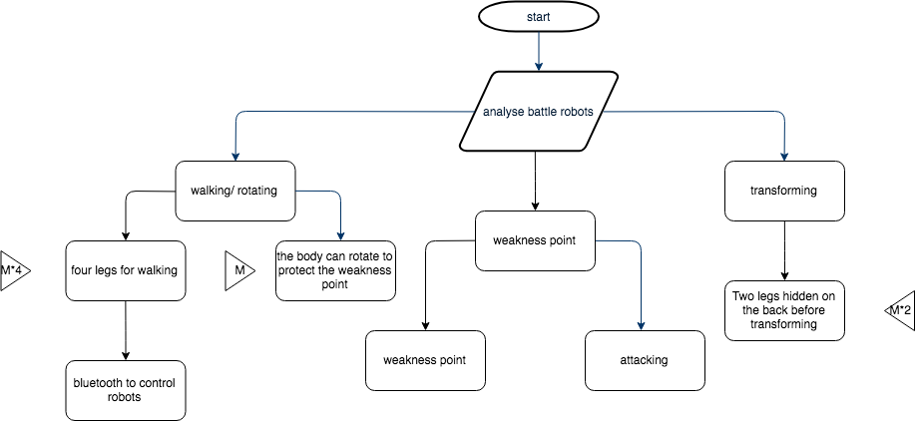

* Major components invovled

**Electronic:**

Arduino uno

Bluetooth module

Motor shield

Step motor

DC motors

* Sketches

